SHABBOS STORIES ANTHOLOGY FOR
ROSH HASHANAH 5777-5778

Compiled by Daniel Keren
From 5777-5778 emails from
Shabbos Stories for the Parsha

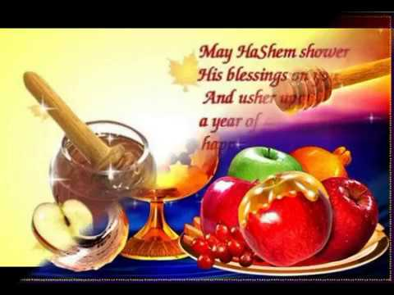
Shabbos Stories for
Rosh hashanah 5777
Volume 8, Issue 1 1-2 Tishrei 5777/ October 3-4, 2016
Printed L’illuy nishmas Nechama bas R’ Noach, a”h

For a free subscription, please forward your request to keren18@juno.com

Tales from the Midrash and Our Gaonim

A Man’s Destiny Is Decreed On the New Year
By Rabbi Sholom Klass

On the first night of Rosh Hashanah, Rabi Shimon ben Yohai had a dream. He dreamt that his two nephews would be fined 600 dinars by the government. The following morning he visited his nephews and persuaded them to become gabaim for the community. They would be in charge of dispensing the charity to the poor. By enabling them to deal in charity, he hoped to avoid the harsh government decree from becoming effective.
“But who will provide us the money to give to the poor of the community?” they asked him.
“You advance the money and keep a record of every penny you lay out. At the end of the year the community will reimburse you,” Rabi Shimon answered them.
They agreed and undertook the job. Sometime later, a jealous person complained to the government that they were dealing in silk and merchandise and not paying taxes. The following day an elderly tax collector appeared and demanded that they pay the government a fine of 600 dinars. They protested their innocence, but the tax collector would not listen to them and they were subsequently jailed.
When Rabi Shimon heard of this matter, he visited them in jail.
“Tell me,” he asked them, “how much money did you raise for charity during the last year?”
“You will find it recorded in a book which we keep in our house,” they answered him.
Rabi Shimon visited their home and began examining their book. He saw that they had laid out 594 dinars, only six dinars short of 600.
Visiting them again in jail he said, “Give me six dinars and I will free you from this jail.’’

The Tax Collector Demands 600 Dinars
“How is that possible?” they asked him. “The tax collector demands 600 dinars and you only ask for six dinars to free us.”
“Regardless,” he answered them, “give me the six dinars and I promise to free you today.”
They gave him the money and Rabi Shimon then visited the tax collector and bribed him to accept the money and forget about the case.
“They have no money to pay you,” he told the collector, “so what will you gain by keeping them in jail? Take these few dinars, free them and drop the case and no one will the wiser.”
The tax collector agreed and he freed them.
When they arrived home they asked him, “How did you know that it would only take six dinars to free us? Did you have any inside information on our case?”

Reveals the Content of His
Rosh Hashanah Dream
“No,” he said, “but last Rosh Hashanah night I had a dream that you would be fined 600 dinars. Counting the money you gave to charity, I figured that you were still six dinars short. Therefore, I knew that the collector would accept the six dinars and he would free you. Great is the power of charity.”
“If you had told us about this at that time we would have gladly donated the entire 600 to charity,” they said, “rather than undergo this aggravating experience and be placed in jail.”
“If I had told this to you at that time,” said Rabi Shimon bar Yohai, “you would never have believed me and you would never have given me any money for charity. Also, I wanted you to really give the money for the sake of charity, not to escape punishment.”

Reprinted from the September 16, 2016 edition of The Jewish Press.

A Slice of Life

Beryl Vogel’s
Trip to the Hospital
By Tzvi Jacobs

The sweet aroma of honey cake and cookies for Rosh Hashana filled the air of Tzipporah's apartment. Tzipporah Vogel and her husband, Aaron Yoseph, lived with their seven children on President Street on the border of the Jewish section of Crown Heights, Brooklyn.
Outside, the school bus stopped across the street from the Vogel's apartment, and 8-year-old Beryl excitedly skipped off the bus, full of anticipation for the coming holiday.
Barely a minute passed when Tzipporah heard a rapid knock on the door. Her 7-year-old son, Levi, ran in, followed by a neighbor's daughter. "Beryl was hit by a car!" the girl shrieked. Tzipporah flew out toward the street.

The Boy Had Been Seriously Injured
A van had driven around the bus, disregarding its flashing red lights, and rammed right into little Beryl, smashing into his head. There were no visible, external signs of injury, but those who witnessed the accident knew that the boy had been seriously injured.
A large crowd of neighbors stood in the middle of the street. Tzipporah darted straight through the crowd and saw her son on the ground.
"Beryleh, Beryleh, it's Mama. Beryleh, Mommy is here," Tzipporah said, as she leaned on the ground next to her son.
No response. "Beryleh, can you hear me? Beryleh," his mother kept repeating. Someone held her back from holding her son. "Don't touch him," warned a number of people. "Hatzalah (the Jewish volunteer ambulance) is on the way."
The police and ambulance arrived two minutes after Tzipporah. The medics paged the City Ambulance to bring spinal equipment to move Beryl.
Aaron Yoseph arrived moments later. As he reached the scene, Beryl was being set onto a stretcher. Before leaving with the ambulance, Tzipporah asked a neighbor to make sure someone would call the Rebbe's office. The woman answered that some one had already spoken to one of the Rebbe's secretaries.
"Beryleh, the Rebbe is praying for you. Now I know you're in good hands," Tzipporah said.
People in the Rebbe's shul were already saying Psalms for Beryl as the ambulance sped to Kings County Hospital, about fifteen blocks away. In the emergency room, Tzipporah continued to repeat her son's name in his ear.
"Okay," Beryl finally responded.
"What hurts you, Beryleh?" Tzipporah asked.
"Ich veis nit (I don't know)," he said, and then slipped back into unconsciousness.
Doctors rushed in and took over, sending Tzipporah out. The corridors of the hospital quickly filled with friends and relatives.

CAT-Scan Revealed Internal
Bleeding and Bruises on the Brain
In the emergency room, the unconscious boy was X-rayed and checked.
Amazingly, Beryl suffered only one broken bone--a rib. However, the CAT-scan revealed a small fracture on the skull and internal bleeding and bruises on the brain. Neurologists were called down to diagnose the severity of the injury. Tubes were inserted into his lungs to keep him breathing, electrodes were taped to his chest to record his heartbeat, and a bolt was drilled into his skull to monitor the pressure on the brain. Even one small bruise on the brain could be fatal if the swelling increased, especially in a child. The doctors were also very concerned about the blood clot expanding.
Beryl was heavily sedated to ensure that he would not move around. The amount of pressure (measured in HUs) on the brain was elevated, fluctuating in the 20s. Anything above 20 HU was very serious. The parents watched the numbers, not knowing which way they would go.

The Eve of Rosh Hashana
The following day, Wednesday, was the eve of Rosh Hashana. Almost all the Jewish doctors were taking off for Rosh Hashana and a long weekend. Many of them said they would say special prayers in their synagogues for Beryl. There was little else the doctors could do; it was clear to all that everything was in G-d's hands.
On the eve of Rosh Hashana, when parents and children customarily call to wish each other a good, sweet year, the news was passed around -- literally all over the world -- to pray for Beryl ben Tzipporah.
On Thursday -- the first day of Rosh Hashana -- Beryl developed pneumonia. In such a weakened state, pneumonia was life-threatening, and the doctors kept trying different medications to fight it. The battle was wearing down little Beryl.
A family member reported each new development to the Rebbe. Aaron Yoseph and his wife watched the brain pressure monitor. Towards the end of the first day of Rosh Hashana -- two days after the accident -- the pressure seemed to be steadily going down. A CAT-scan on Friday revealed that the bleeding in the brain had stopped. The doctor instructed the nurses to stop giving Beryl sedatives, unscrewed the monitor mounted on Beryl's skull, and removed the machinery from his lungs and mouth. Immediately, Beryl wiggled his head and his torso. Within a minute, he slowly opened his eyes.
"Good Yom Tov, Beryleh," said Tzipporah, with tears in her eyes. "It's Rosh Hashana."

Softly Singing “Avinu Malkeinu”
Tzipporah started softly singing the Rosh Hashana prayer "Avinu Malkeinu." "Avinu Malkeinu Chatanu Lefanecha -- Our Father, Our King, we have sinned before You..."
"Mama, on Rosh Hashana, you don't say 'Chatanu Lefanecha,' " Beryl said.
Tears of joy and relief flowed from Tzipporah's eyes: Beryl's mind was as sharp as ever. Beryl saw the tzedaka box and picture of the Rebbe that his parents had put in the room. He smiled.
"Mama, can I hear the shofar?" Beryl asked.
"Aaron Yoseph, Beryleh wants to hear the shofar!" Tzipporah cried out.
Aaron Yoseph came into Beryl's room and softly blew the shofar for his son with all his heart and soul.

The Doctor’s Uncharacteristic Smile
On Saturday afternoon, Dr. Sherman, the resident who had conscientiously worked with Beryl from the very beginning, reported to Tzipporah, "Your son still has an elevated temperature." Then, with an uncharacteristic smile, he added, "But he's recovering very quickly."
That night, Tzipporah spoke again to Dr. Sherman about Beryl's condition. "You know your son is very, very lucky," he said. He was silent for a moment and then hesitatingly asked, "Have you been in touch with Rabbi Schneerson?"
"The Rebbe? Of course. The family has been in touch with the Rebbe from the very beginning," she said. Then, with a serious look added, "Doctor, we all pray to G-d and He hears everyone's prayers, but the Rebbe's prayers are heard and answered."
On Tuesday, only one week after the accident, Beryl dressed himself. His shoes, which were brand new before the accident, made him realize how lucky he was: the sole of his left shoe was rubbed paper thin by the accident. The hospital released Beryl and his father drove him home.
While Aaron Yoseph was helping his son out of the car, Beryl said, "It feels like I'm now finishing crossing the street."
"And I," said Tzipporah, "feel like I'm coming home from the hospital with a newborn child."

Reprinted from the Rosh Hashanah 5756/1996 issue (#435) edition of “L’Chaim Weekly,” a publication of the Lubavitch Youth Organization in Brooklyn, NY. Excerpted from “Truths Revealed” by Tzvi Jacobs.

High Holidays in
Samarkand Highlighted
By Tearful Prayer
By Hillel Zaltzman

The High Holidays in Samarkand were an experience unto themselves. From the beginning of the preceding month of Elul, a change could be discerned in the atmosphere. The people of the community grew introspective, as each individual tried to improve on his or her own religious observance and focus less on material pursuits. One could sense that the Days of Awe were approaching.
The two days of Rosh Hashanah were solemn and awe-inspiring. Our minyan took place in a private home, and was made up of some fifteen to twenty men, each person sitting in his place, totally immersed in prayer. We were very careful not to utter anything unrelated to the holiday, and even when we needed to communicate, we preferred to motion with our hands so as not to get caught up in idle talk. Every free moment was devoted to reciting Psalms.
At one point, we found out about the Lubavitch custom to arrange, by roster, for the Psalms to be recited continuously throughout all forty-eight hours of the holiday. One could sense that the Days of Awe were approaching. Although there weren’t enough people between us to arrange a full minyan for each shift, we divided up the hours and each of us took a shift. The shifts would begin ten minutes early and end ten minutes late, so as to ensure a seamless transfer, without any interruptions. In that manner the Psalms were recited constantly, with the exception of the times of the actual prayer services.

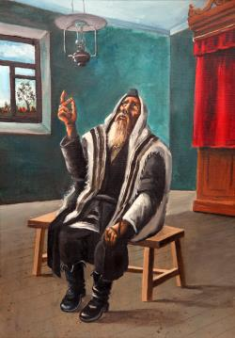
Grandma's painting of her grandfather praying.

As I write this, the memories draw me back to those wonderful days. I find myself back in shul for the High Holidays, and it is hard for me to describe the feelings that engulfed us in the small room our minyan was held in.
R. Berke Chein stands in one corner, covered with his tallis and saying Psalms in a soft and tearful voice. R. Moshe Nissilevitch stands in another corner, words gently drifting from his mouth. Dovid and Eliyahu Mishulovin sit with their prayer shawls over their heads, reciting Psalms with tremendous concentration, and so on.
As the minyan started, everyone began to daven with intense focus, each person as their ability and energy allowed them. Each person looked inside his prayerbook and uttered every word clearly, trying his best to think over the meaning of the Hebrew words.
My father had managed to get a hold of a traditional Chabad Tehillas Hashem prayerbook from an individual in Moscow. His desire to acquire it was so great that he paid 700 rubles to buy it from him—the equivalent of an entire month’s salary! After we had obtained the Tehillas Hashem, we were able to more accurately recite the prayers according to our custom.
When the leader reached the Shemoneh Esrei, the silent portion of the prayers normally recited together with the minyan, some congregants would still be making their way through the various earlier stages of the prayers. Although we always made sure we had enough people together before beginning Shemoneh Esrei and enough people ready to answer to the Leader’s Repetition, we never tried to hurry anyone. We simply didn’t dare interfere with someone else’s prayer.
This we didn’t dare interfere with someone else’s prayer silent prayer always had a unique aura; whispered voices rose and fell, with the sound of quiet sobbing in the background. One cried, another sighed, and yet a third shed tears silently onto the pages of his prayerbook.
After the Leader’s Repetition on Rosh Hashanah, we tried to wait for those who were still praying on their own so that they too could be together with the minyan when the time came for the blowing of the shofar; while waiting, the others recited Psalms. With Reb Berke leading the proceedings, the shofar-blowing ceremony, including its prefatory prayers, lasted an hour. His tears would intermingle with drops of sweat, soaking his prayerbook and the table he stood at.
After prayers of this intensity, even the way we walked down the street on the way back home was changed. We walked with a focused mindfulness, our heads bowed, looking only within our immediate vicinity. We hurriedly ate the festive meal so as to provide sufficient time for the afternoon prayer and the riverside tashlich ceremony. If I do not err, R. Berke would fast during the two days of Rosh Hashanah, partaking only of the two nighttime meals.
I particularly remember Yom Kippur in Samarkand. R. Moshe Nissilevitch would come to the house where the minyan was held, with his prayerbook and Psalms, and remain there until after the fast. From the time he entered the house, he would stand opposite the wall, covered with his tallis, murmuring words of Psalms or praying quietly.
R. Moshe always made an effort to stand the entire day. He said it was his father’s custom, and it was one that he kept his entire life. This was his Yom Kippur: completely engrossed in his prayers, oblivious of the goings-on around him; he still cried as he prayed always praying at his own pace, even if the minyan was ahead of him.
His quiet, hoarse voice could barely be heard, and every so often a tear would make its way down his cheek. His Shemoneh Esrei was quite lengthy, as he tried to enunciate each word properly. He would often repeat words of the prayers, apparently to ensure that he had pronounced each one just so. He would be extremely careful not to utter any unnecessary words outside of the prayers.
After leaving Russia, it was difficult to become accustomed to the different type of conduct we observed elsewhere. During my first Rosh Hashanah in Israel, I still cried as I prayed; but to be honest, those tears were less from the atmosphere of Rosh Hashanah itself than from my longing for Rosh Hashanah in Samarkand.

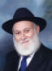

Excerpted from the upcoming book Samarkand, by Hillel Zaltzman. Hillel is the director of Chamah, an organization which works to share the beauty of Judaism with immigrants from the former USSR. To help bring this book to fruition, please contact the author.

Reprinted from the Rosh Hashanah website of Chabad.Org

Rosh Hashanah Thoughts
By Rabbi Aron Moshe Jacobsohn

Rav Aharon Kotler, zt”l, noted that the essence of Rosh Hashanah is establishing the Kingship of Hashem. This is twofold, recognizing that Hashem is the All-Capable King, as well as understanding that we are His nation, His servants.
Rav Simcha Zissel of Kelm (Chochmah U’Mussar II, 152) notes that an integral aspect of being the nation of a king is unity. To be a nation, we all have to work together with a unified attitude.
Once, my father was shopping at a local hardware store for a few tools he needed for a project. When he asked a store employee for assistance, an older Jamaican fellow who was clearly not an employee asked to be able to care for my father’s requests.
After helping him find all the items he needed for the project and making sure to explain the best ways to utilize each item, the fellow offered an explanation for his generosity. “It says in my bible, as strange as it may seem, that you Jews are the chosen nation. It also says that if we help you, we will be blessed, and that is why I try to help your people whenever I have the opportunity.”
Let us imagine for a moment how the world would be if we treated each other with the approach of recognizing that our fellow is part of Hashem’s nation. If we respect each other and care for each other with this approach, we would see such a beautiful world. This would enable us to have the requisite unity to approach the New Year, to properly recognize Hashem’s sovereignty and be able to overcome our differences. May you and your families merit to be written in the Book of Life for a happy, sweet and successful year!

Reprinted from the Rosh Hashanah 5776 email of Torah U’Tefilah: A Collection of Inspiring Insights compiled by Rabbi Yehuda Winzelberg.

Rosh Hashanah Treasures

The Secret of the
Coming Year (Shanah)

The Satmar Rebbe, zt”l, once made an insightful comment on the pasuk, “Blow the Shofar on the moon's renewal, at the time that the moon is hidden (ba’keseh), appointed for our festive holiday” (Tehilim 81:4).
Rosh Hashanah is the only Yom Tov on which the new moon is not yet visible. Since Rosh Hashanah falls out on the first of Tishrei, the holiday is observed when the moon is hidden. The Satmar Rebbe gave a deeper meaning to the ‘hidden’ aspect of Rosh Hashanah, and that is the fact that we will not learn what type of Rosh Hashanah it will be until the end of the year. We don’t know ahead of time how our year is going to turn out, and it is a very frightening thing. Not until right before sunset on Rosh Hashanah can one know how the previous year has turned out, and until then, it is ‘ba’keseh’, hidden, and we must put our trust and faith in Hashem that He will take care of us and do what is best for us. This is one aspect of declaring Hashem our King on Rosh Hashanah. Rav Chaim Shmulevitz once said that we may see an older person with a weakened immune system catch a cold in the middle of the winter, which worsens and worsens, and people attribute the cause to the harsh winter. However, such calculations are incorrect, as the person actually caught the cold on Rosh Hashanah, because that is when it was determined exactly what was going to happen later that winter. This is the awesomeness of the day of Rosh Hashanah, where Hashem our King decides what our year will look like.

Reprinted from the Rosh Hashanah 5776 email of Torah U’Tefilah: A Collection of Inspiring Insights compiled by Rabbi Yehuda Winzelberg.

An “Unusual” Rosh Hashanah Concert in Spain

In Spain of August 1492, all Jews were ordered to leave the Spanish kingdom. King Ferdinand and Queen Isabella had recently conquered all of Spain and sought to make their new kingdom an entirely Christian nation. No Jews could remain. Thousands of Jews fled, and within days, the Jewish community of Spain, which had flourished for hundreds of years, had ended.
However, not all of Spain’s Jews had fled. It was possible to remain in Spain, but every Jew had to publicly convert to Christianity and renounce all Jewish observance. Many Jews lived outwardly as goyim in public, but held on to their Jewish observance in secret.
On Friday nights, these secret Jews would shutter their windows so neighbors wouldn’t see them light Shabbos candles. They would bake their challah in hiding, and would whisper the words of the Kiddush. They knew their lives were at stake if they were ever discovered. The Spanish Inquisition had begun years before, and Jews were frequently killed when their secret Jewish lifestyles became known.
Even though these Jews had apparently embraced Christianity, the secret Jews of Spain were never trusted by the Spaniards. They called these Jews “Marranos”, a disparaging term that means “pigs”, and many looked for any sign of Jewish practice in order to turn them over to the Inquisition.
There was a large group of these secret Jews in the city of Barcelona who clung to their ancient traditions. One person, a prominent Jew named Don Fernando Aguilar, was the conductor of the Royal Orchestra in that city, and he enjoyed great wealth and prestige. He privately kept all the mitzvos he could. When he would come home each night, he kissed a Mezuzah that he kept hidden in his floorboards. He was careful to eat only Kosher food and observe the Jewish holidays.
Some Mitzvos, however, were nearly impossible to observe, like hearing the Shofar on Rosh Hashanah. Blowing a Shofar out loud would lead to an immediate arrest, and death. After five long years of living this secret life, Don Aguilar saw an opportunity. In 1497, he made a public announcement, that on Sunday, the 5th of September, he would personally lead the Royal Orchestra of Barcelona in a brand new concert of his own composition, and the piece he had written was unlike anything ever heard in Spain before.
He declared that it was going to be a musical celebration of different people and cultures from around the world, featuring every instrument ever invented from across the globe, no matter how far away. The only thing he didn’t announce was that it was also the first day of Rosh Hashanah. He generated much excitement for his concert, and on the day of the performance, the orchestra hall was filled with an over-flow crowd.
Also in attendance were those “Marranos”, but nobody seemed suspicious of them. As the concert began, Don Fernando Aguilar was true to his word, the audience heard interesting music from a wide range of instruments. There were bells and horns, stringed instruments and an array of different drums.
Then, in the middle of the concert, a musician with the orchestra who was rumored by many to be a secret Jew took the stage. He was holding an unusual instrument: a ram’s horn. The musician put it to his lips, and began to blow. He blew a Tekiah, a Shevarim, and a Teruah. Each note of the Rosh Hashanah Shofar service rang out throughout the hall, one hundred notes in all.
Most of the audience appreciated it as a skillful performance of an unfamiliar instrument, but to the secret Jews in the audience, Don Aguilar’s “music” gave them their first chance in years to fulfill the mitzvah of hearing the Shofar! (The Book of Our Heritage, Rabbi Eliyahu Ki Tov)

Reprinted from the Rosh Hashanah 5776 email of Torah U’Tefilah: A Collection of Inspiring Insights compiled by Rabbi Yehuda Winzelberg.
Those Were the Days
By Larry Gordon

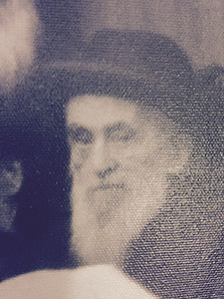
Rabbi Moshe DovBer Rivkin, a’h

“Er hut zich azoy ois gevaynt.” It was on Rosh Hashanah, during the reading of the haftarah of the first day of the New Year, and Rav Moshe DovBer Rivkin was inconsolable. The reading is from Sefer Shmuel aboutShmuel HaNavi’s mother, Chana, who was childless at the time.
She desperately wanted children and beseeched G-d with a passion and a profound sense of helplessness, hoping that this time He would not be silent, would answer her prayer, and allow her to conceive and give birth to a child.
Chana’s experience and tefillah in the Book of Samuel, our sages tell us, is the baseline of the best manner in which we should pray, in particular on Rosh Hashanah.
The setting for the reading of this haftarah was the library of the Friediker Rebbe, the previous Lubavitcher Rebbe, Rabbi Yosef Yitzchok Schneerson, on the upper floor of Chabad world headquarters at 770 Eastern Parkway in Brooklyn.
I don’t know the specific history of how Rabbi Rivkin, who at the time was aroshyeshiva at Torah Vodaath, was the elder statesman or the leader, so to speak, of this minyan that was only held on the two days of Rosh Hashanah and on Yom Kippur. My father was the ba’al Mussaf, and on Yom Kippur the ba’al Mussaf and Neilah, as well as the ba’al kriah.
My bother Yossy and I were somewhere between 8 and 14 years old, just there to daven and observe, so that these impressions and memories of special and precious days can last a lifetime.
As a kid, I would marvel and fail to understand how Rabbi Rivkin was not more self-conscious about sobbing uncontrollably in front of so many people. As I got a little older and studied the story he was reading, I began to understand what he was weeping about as he was overcome with emotion.
A friend that I met in the neighborhood the other day asked me if I was going to write this year about my Rosh Hashanah minyan experience at the top of 770. He was referring to an essay on the experience that I reran in these pages several times over the last 15 years. I thought about it for a moment and then decided that I would broach the subject again, but that I needed to reflect additionally on that experience of so long ago and see what I could still conjure up.
I mentioned to this person that it was interesting how Rabbi Rivkin would cry so much each time he read the haftarah even though he knew the story and how it ended from previous years. But that was supposed to be an attempt at a little comedy and nothing more. I knew early on that he wasn’t weeping about the sad story of a childless woman, though there is plenty to lament about those circumstances.
The rabbi was crying because that experience of Chana crying in the Mishkanin Shiloh is representative of what it means to daven effectively and ultimately with success.
As the reader knows, the haftarah recounts how the kohen, Eli, observed Chana with her lips in motion though without any discernible sound. Eli, after watching this scene, said to Chana: “How long will you be drunk? Remove your wine from yourself.” To this Chana retorted, “It is not so, my lord, I am a woman heavy of heart. I have drunk neither new wine nor old wine. But I have poured out my soul before the L-rd. Do not regard your maidservant as a wicked woman, for it is due to my great distress and vexation that I have been speaking until now.”
Eli replied to these words by saying, “Go in peace and the G-d of Israel will grant your request which you have asked of Him.” There is more to the haftarah, including the birth of Shmuel and his being dedicated to serve Hashem with rare devotion and fervor all of his life.
As far as I can recall, this was the part of the haftarah at which the rabbi sobbed so much that he could not continue. This story is not only recounted because of the success of Chana’s prayer and the birth of Shmuel HaNavi. From this—as we head into Rosh Hashanah 5776—we understand the formulation and components of not just how to pray, but the all-too-distant reality that if our hearts and minds are in the right place, prayer—especially at this time of year—can take us to high places with our wishes and hopes coming to fruition.
So almost a half-century after those beautiful and innocent days, I wonder what it was that my father was davening about, what was on his mind; perhaps sufficient time has elapsed for me to draw some conclusions about those prayers.
No doubt, as all people do, he prayed for health and happiness, and success in all his and the congregation’s endeavors. And he probably also prayed for nachas from his children and now grandchildren, which now in a different realm I am sure he—and my mom, may she continue to live and be well—is having and enjoying.
In the early years, Rabbi Rivkin was also the one who blew the shofar in this minyan of about 30 or 40 people. I must have been in my teens when he just had no koach to continue. I can recall him making a determined effort to belt out those tekios, but there came a time when he just could not do it anymore. That’s when he handed off the shofar to one of the younger men in the shul, who stepped up and right into his appointed role and blew with a youthful, authoritative vigor, signaling an unexpected changing of the guard. From that day forward, it was the new younger man who kept the shofar with him in his tallis bag—the job, so to speak, was his.
I relive these moments so as to take a cerebral tour with you of a Rosh Hashanah past, which I could have just as easily done by searching my document file and presenting the original piece that I wrote on this subject a decade or more ago. But if I’d done that, I wouldn’t have had to think back and recall some of these special moments of the past, which, when I picture them, come up not just fresh, but alive in my mind’s eye.
The Friediker Rebbe’s room was relatively small. It was surrounded on four sides by glass-enclosed bookshelves packed with sefarim. The glass doors were locked; I never saw them open. This took place in the 1960s and early ’70s, though the Rebbe had passed away in 1950. Rabbi Yosef Yitzchok Schneerson was not a well man, and on Shabbos and Yom Tov, because he was in a wheelchair, he could not descend to the main minyan in 770. He suffered with multiple sclerosis and then toward the end of his life had a stroke and lost his ability to speak.
But as history has recorded, and despite his infirmities and difficulties, he was a man of great vision with a fierce determination to rework the American spiritual landscape and bring Jewish education and Torah to a land that many perceived as being a material oasis and an opportunity to establish new lives free of what many saw as the constricts of Jewish religious life.
“America iz nisht andrish,” he was wont to say. It was his credo, his battle cry that his son-in-law, the next Rebbe, would carry on. That is, “America is no different.” That which worked and took hold in Europe 1,000 or more years could be transplanted, cultivated, and successfully grown here in the New World in the United States of America.
And a great deal of those battle plans were developed right up there in these rooms where the Rebbe lived, worked, studied, and prayed, which in retrospect were all one and the same. The history is deep and rich, and I glean bits of it from what I hear from people and what I read in some of the books about Chabad that have been on the market for a few years now.
My father davened smoothly, with earnestness and an understanding of the task at hand. To me it looked like he was satisfied with his life and what he had accomplished. He approached the task of leading this minyan in these hallowed environs with both seriousness and a businesslike nonchalance.
These are not just the memories alone but the lessons of Rosh Hashanah—that despite the hardening of a generation, we should not be afraid to break ourselves down to the point where we can attach ourselves to our all-powerful G-d.
Rabbi Rivkin didn’t cry only because the story of Chana was a sad one. He wept so uncontrollably because those biblical events provided a key and a conduit to the understanding of how despite our personal circumstances, we possess the ability to break through and evoke a clear response to our heartfelt tefillos on Rosh Hashanah.
The story is told about a wealthy chassid who came to the Rebbe before Yom Tov for a berachah. He was getting older and experiencing some health issues. Before the Rebbe could bless him, the chassid told the Rebbe that in the year ahead he would not mind if he had a little less parnassah but better health.
The Rebbe listened intently to the chassid’s request, but then admonished him, saying that the Creator of the Universe, Our Al-mighty G-d, does not have to make deals like that. “Hashem has the ability to give you the maximum and the best of both.”
Let us all hope and pray for that type of uncompromising beneficence and magnanimity from the One Above in the New Year ahead. Shanahtovah to all.
Comments for Larry Gordon are welcome at editor@5tjt.com.

Reprinted from last year’s September 11, 2015 edition of the 5 Towns Jewish Times.

Hashem, You Are My King
By Rabbi Moshe Meir Weiss

On Rosh Hashanah, after the tekios in musaf, we say “Hayom haras olam – On this day the world was created.” This is difficult to understand since the world was created on the 25th day of Elul, six days before. The universal answer given is that on Rosh Hashanah Hashem created man (on the 6th day of creation) and it is only then that He became King. For, in order to be a king you need to have subjects.
This after all is the central theme of Rosh Hashanah, to re-inaugurate Hashem as our King. This is why we say tashlich by the water, since kings were appointed by the water. This is why the chazzan, after nishmas, says HaMelech in a haunting melody, to accentuate that Hashem is our King. This is one of the symbols for the shofar ritual, to coronate Hashem as our Supreme Ruler.
It behooves us, in order to make our Rosh Hashanah experience spiritually meaningful, to reflect upon what it means that we are renewing our commitment that Hashem is our King. Here are some ideas.
1) As a Torah Jew, we can’t do what we want. Rather, we do what our King tells us to do. We want to sleep in but the King says we have to go to shacharis. We want to peek at the women passing but the King says, “Lo sasuru acharei levav’chem v’acharei eineichem – Don’t turn aside to follow your heart and your eyes.” We want to lie to get out of a sticky situation, but the King says, “Midvar sheker tirchak – From any falsehood you should distance yourself.” We want to explode and scream at our spouse, but the King says, “V’ahavta l’rei’acha k’mocha – Love your fellow as yourself.” And many, many more such examples.
2) As subjects of our King, we proudly bear the King’s seal with our bris milah, which is Hashem’s coat-of-arms. Similarly, we wear with distinction Hashem’s insignia with our yarmulke, tefillin, tzitzis, sheitlach, snoods, and tichels.
3) We will be more aware that our tefillah/prayer is a privileged opportunity to have an audience with the King. We will therefore dress appropriately, pay attention accordingly, and realize that our prayers, when listened to, can make a huge difference in our lives.
4) Our Shabbos experience is a weekly affirmation that we are the subjects of an All-Powerful King Who commands us that once a week we should desist from any creative labor to remember that we are His complete and loyal subjects.
5) Reaffirming that Hashem is our King, we commit ourselves to making His will the decisive factor in our decision making, thus fulfilling the all-important command, “Es Hashem Elokeichem tirah – To fear and be aware of your G-d,” which the Ramban teaches us is the positive commandment to use the fear of G-d as an inhibition from doing something wrong and an incentive to live properly.
Knowing that Hashem is our Supreme Commander, we will mightily strive to give Him nachas which is fulfilled by emulating His ways. Just as He is merciful, we will be merciful.Just as He is gracious, we will be gracious, and we will give Him “pleasure” by occupying ourselves with His greatest love which is the learning of Hashem’s Torah.
In the merit of the coronation of Hashem as our King, may He bestow upon us long life, good health, and a sweet and wonderful New Year.

Reprinted from the September 23, 2016 edition of the Matzav.com website.

The Fireman
By Nissan Mindel
Published and copyrighted by Kehot Publication Society

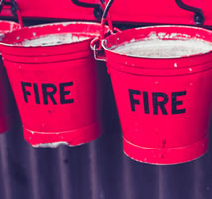

Many, many years ago, before there were any fire engines or fire brigades, or electric fire alarms, and most houses were built of wood, a fire was a terrible thing. A whole town, or a good part of it, could go up in flames and smoke. And so, when fire broke out, everyone left his business or work, and rushed to help put out the fire. There used to be a watchtower that was taller than the other buildings, where a watchman kept a lookout all the time. As soon as he saw smoke or fire, he would sound the alarm. The townspeople would then form a human chain between the fire and the nearest well, and pass on to each other pails of water with which to put out the fire.
Once it happened that a lad from a small village came to town for the first time. He stopped at an inn, on the outskirts of the town. Suddenly he heard the sound of a bugle. He asked the innkeeper what it meant.
"Whenever we have a fire," the innkeeper explained to the lad, "we sound the bugle, and the fire is quickly put out."
"How wonderful!" thought the village lad. "What a surprise and sensation I will bring to my village!"
Thereupon, the village lad went and bought himself a bugle. When he returned to his village, he was full of excitement. He called all the villagers together. "Listen, good people," he exclaimed. "No need to be afraid of fire any more. Just watch me, and see how quickly I will put out a fire!"
Saying this, he ran to the nearest hut and set fire to its straw roof. The fire began to spread very quickly.
"Don't be alarmed!" cried the lad. "Now watch me."
The lad began to blow the bugle with all his might, interrupting it only to catch his breath, and to say, "Wait, this will put out the fire in no time!" But the fire did not seem to care much for the music, and merely hopped from one roof to another, until the entire village was in flames.
The villagers now began to scold and curse the lad. "You fool," they cried. "Did you think that the mere blowing of the trumpet will put the fire out? It is only the call of an alarm, to wake up the people, if they are asleep, or to break them away from their business and work, and send them to the well to draw water and put out the fire!"
We are reminded of this story when we think of the shofar that is sounded many times on Rosh Hashanah. Some people think like that village lad, that the sound of the shofar itself will do everything for them. They think that they may continue to "sleep," or go about their business, there being no need to change their way of life and daily conduct; the shofar sounded in the synagogue will surely bring them a happy New Year.
But, like the bugle in the story, the shofar is but the sound of an "alarm." It has a message: "Wake up, you sleepers, think about your ways, return to G-d, put out the 'fire' that is threatening to destroy your Jewish homes. Go to the Well, the Well of Living Waters, the Torah and mitzvot. Hurry, before it is too late!"
That is why, immediately after the shofar is sounded, we proclaim: "Happy are the people who understand the meaning of the sound of the shofar; they walk in Your light, O’ G-d.”

Reprinted from the website of Chabad.Org
How an American Executive Dropped Everything to Become Israel’s Shofar King
By Naomi Zeveloff

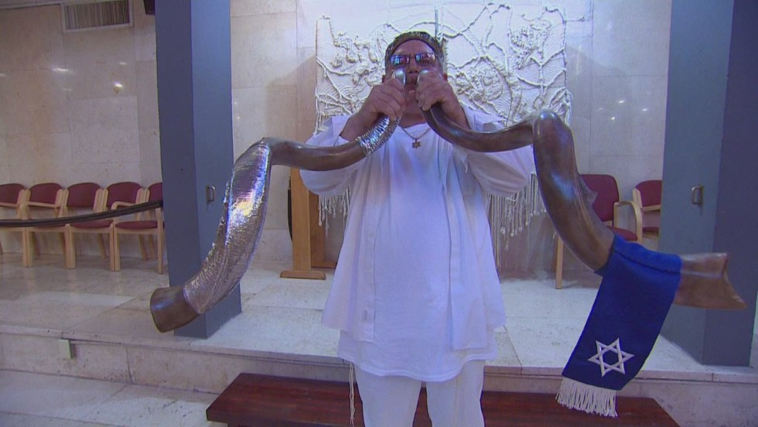
Robert Weinger blowing two shofars simultaneously

In 2008, Robert Weinger was divorced, middle-aged and had ended a 23-year career as an executive in the beverage industry, when he took a trip to Israel with his synagogue that would change his life.
His tour group was standing atop Mount Bental, a dormant volcano in the Golan Heights, when a fellow tourist asked Weinger to hold the shofar he had recently purchased while he used the restroom. Weinger casually placed the horn to his lips, and to his great surprise, Israel’s ceremonial flag-raising tune came out. Around the same time, a small earthquake rattled northern Israel.
Weinger would later see it as a sign from above: “With the voice of G-d, the earth shall quake,” he said, paraphrasing Psalm 29 in the Hebrew Bible.
Today at 65 he is a West Bank settler and shofar aficionado, both a peddler and a player of the horn Jews sound during on Rosh Hashanah and Yom Kippur. Weinger’s path from Northern California beverage executive to Israeli shofar maestro is a long and meandering one. It is a spiritual journey that took him from one of the highest points in California, on Mount Diablo, to the lowest point on earth, the Dead Sea, he likes to remark.
In the 1980s and ’90s, Weinger was a bulldog sales and marketing chief, working at companies that produced Gatorade and Monster Energy. When a business disagreement left him unemployed, he began to re-evaluate his life. A “burning bush” style encounter in the hills outside San Francisco led him to believe that he can speak directly to G-d.
Weinger later found himself busking for shekels with his shofar on the streets of Jerusalem. Now living in an aluminum shack in the desert near the Dead Sea, he said he has been “humbled” by G-d. Yet his is a spirituality infused by business acumen. He is marketing the shofar as a divine tool, using his unlikely personal story as advertising copy to “call the children of Israel home.”
Seven years after that first earth-shattering blast, he sold his 3,200-square-foot ranch house in affluent Diablo, California, packed up his belongings and moved into a trailer in a settler outpost near the Dead Sea. He decided to devote his life to the shofar, which he believes is a direct conduit to G-d.
Weinger is a master shofar sounder, with a distinctive style of blowing two 3.9-foot-long shofars at once. (The idea came to him at midnight on Ben Yehuda Street in Jerusalem, when, he says, he heard the voice of G-d say “shtayim,” or “two” in Hebrew.)
His company, Shofar So Great — which is still based in the United States while Weinger is in the process of becoming an Israeli citizen — sells Israeli-made shofars to Christians and Jews around the world. The goal is to outfit the “army of the L-rd with the clarion sound of heaven,” according to its website.
With Rosh Hashanah, the Jewish new year celebration at which the shofar is sounded, fast approaching, Weinger is playing his shofar across Israel and in Jewish settlements in the West Bank. He is also doing a brisk business in shofars, selling some for as much as $3,000.
“This is my time,” he said, sitting in the shed that he calls home, where a tattered poster that reads “The Temple Mount Will Be in Our Control” hangs above the bed. “The shofar is a wakeup call. We are waking ourselves up spiritually to return to Hashem and his ways.”
Born in 1951 in Los Angeles to a stay-at-home mother and a father who worked in glass repair, Weinger was the middle child in what he calls a “first-generation post-Holocaust traditional Jewish American family.” His family was observant, and Weinger came to resent Hebrew school because it prevented him from playing sports on the Sabbath. He played the horn in middle school, but he stayed away from the shofar, which was his elder brother’s favorite instrument.
At age 23 he married his college sweetheart — they would later have a daughter together — and went on to receive a master’s degree in communications from California State University, in Sacramento. Weinger, who delights in making links between the two disparate halves of his life, believes his topic of study was preordained. The shofar’s blast is a “spiritual communication,” he said, pinching the rim of a gleaming shofar made from the horn of the greater kudu, a woodland antelope from South Africa.
Weinger’s first job was in sales at General Foods, selling the powdered drink mix Tang to grocery stores. In 1986 he began working for the Gatorade division of Quaker Oats, marketing the beverage to professional sports teams. The job came with high-end perks, like courtside seats at basketball games. Today, Weinger, still an avid sports fan, watches games using the internet connection at the Last Chance Tavern, six miles from the outpost where he lives. In the 1990s, Weinger left Gatorade and later became the vice president of sales at the Hansen Beverage Company as part of the team that helped to create Monster Energy. He declined to provide specifics about his financial status at the time, but said that “on paper” he was a millionaire.
He left Hansen Beverage Company in 2001 when he had a “falling-out” with the CEO. With ample time on his hands, he went on frequent hikes on Mount Diablo, pondering over what to do with his life. He began thinking about what kind of legacy he would leave behind, and realized that his identity was “tied up into that title under my name on my business card.”
One day, while on a hike, Weinger, who at that time was not particularly religious, said he had a “burning bush experience.” Though there was no obstacle in his path, he felt that he had a hit a physical wall, and he fell to his knees. Weinger recalled a “sense of joy and peace and exhilaration.”
“I began to sob, I began to weep,” he said. “It was in that moment that I recognized there was a presence bigger than me, a presence other than me, that G-d was real.”
Weinger began to experience what he calls “G-dfirmations,” or affirmations from G-d that he was on the correct path. When pressed for an example, he mentioned attending a San Francisco Giants game with a college friend. He predicted that famous left fielder Barry Bonds would hit a home run into their section near center field. His friend balked, but lo and behold, Bonds hit the ball straight to Weinger, he said.
“I got the ball,” Weinger said. “I was the lead story on SportsCenter.”
Weinger began exploring Judaism and started to attend his synagogue regularly. One day, he overheard some fellow congregants speaking about a trip to Israel and decided to join. “I said, ‘Gee, I haven’t had a vacation in a long time.’” He had been to the Holy Land only once, after college graduation, on a trip with his ex-wife, which he funded with his bar mitzvah money. Back then, he found the country to be a “hard place, not very comfortable,” he said.
After Weinger’s experience with the shofar on Mount Bental, he went back to the Old City and purchased two shofars, one for himself and one for a friend. While his tour group went back to California, Weinger stayed for another two weeks. He began busking in Jerusalem, and found that his shofar playing seemed to touch passersby. The sound of the shofar “resonates in the blood of a Jewish person,” he said.
Apparently, it worked with Christians, too. One day, a group of Chinese Christian pilgrims heard him playing on the street and invited him to come to their conference as a shofar vendor. He scoured Old City shops and bought 35 shofars that had decent pitch. By the end of the conference he had sold them all. The pilgrims, a group that was fond of puns, deemed Weinger’s efforts “shofar so good.”
With his background in sales and marketing, Weinger thought the moniker could be a perfect company name. He emailed his idea to a friend, who emailed him back to say that the domain name shofarsogood.com was taken. Weinger was devastated. He said he spoke to G-d: “I am ruined.” Then, he heard a voice in his head: “‘You are better than good. You are great. You are Shofar So Great.’”
The next day, he went to an internet cafe in downtown Jerusalem and registered shofarsogreat.com, shofarsogreat.org, shofarsogreat.biz and shofarsogreat.tv. Building the website was another “burning bush” experience, he said; it allowed him to create a rudimentary design on his own: “I had the experience of seeing my hand create it.” (He also had some technical help from GoDaddy, the internet web-hosting company.)
Before he left Israel, Weinger bought 22 shofars, making sure that each one could play five harmonic notes, which has since become his standard for all Shofar So Great horns. He brought them back to California. Eventually he sold all 22 and began going back and forth to Israel.
On one trip, he visited Christian friends who were volunteering at Beit Hogla, a tiny caravan outpost a stone’s throw from the Dead Sea in the Israeli-occupied West Bank. The Israeli government considers the outpost unlawful construction, even as it sanctions other settlement building. The international community, meanwhile, rejects all Israeli settlements as illegal.
Beit Hogla was founded by Erna Covos, a 68-year-old Greek immigrant to Israel. She felt a spiritual attachment to nearby Jericho, a biblical era city that is now a Palestinian vacation town. After the Oslo Accords, when the Palestinian Authority gained control of Jericho, Covos tried to stay in a Byzantine-era synagogue in the city. But at the beginning of the Second Intifada, vandals set fire to the synagogue — which the Palestinian Authority later repaired — and the Israel Defense Forces booted her out, she said.
Covos established Beit Hogla in order to be close Jericho, eventually hooking up the shacks there to water and electricity and planting olive, date, fig and pomegranate trees. With a sweeping view of Mount Nebo, the Jordanian range from which Moses supposedly first spied the Promised Land, Beit Hogla is home to six families and 180 pigeons. Covos is raising the birds to be used as an animal sacrifice for a restored Jewish temple in Jerusalem, a messianic vision that she hopes will come true in her lifetime.
Beit Hogla’s proximity to Jericho also struck a chord with Weinger. In the Old Testament, the Israelite army caused the walls of Jericho to fall by blowing six shofars. Weinger said he heard G-d speaking to him at Beit Hogla, telling him he had “authority” over the land and that he should use it as a base from which to “call the Children of Israel home.” (In actuality, the authority of the land is in question. According to Hagit Ofran, the director of Peace Now’s settlement watch program, Israel has deemed it state land. Palestinians, on the other hand, claim it as part of their future state.)
Hearing G-d’s voice, Weinger began to weep. Though he doesn’t carry a handkerchief, he said he miraculously discovered one in his pocket. Covos saw him crying, he said, and told him she wanted him to build a “shofar spiritual center” on the property. Covos remembers it differently, saying that Weinger was the one who approached her with the idea.
Weinger knew he wanted to immigrate to Israel, but he was daunted by the logistics of leaving his comfortable life in Diablo behind. Then, while in Israel, he got a call from his house sitter that a pipe broke in the bathroom and had flooded the house.
When he returned to California — on the day of the Torah portion about Noah and the ark, he noted — he saw that the damage was much worse than he thought. His home was filled with mildew. Weinger decided to upgrade his home in the cleaning process, and boxed up his belongings. Suddenly it didn’t seem so difficult to relocate to Israel. The flood was another “G-dfirmation,” he said.
Weinger worked on the Diablo house for a year and became close with his contractor, George Cohen, a Jew from Transylvania. Weinger invited Cohen to move to Beit Hogla with him, and now the two are roommates. They are just friends, Weinger relayed, unsolicited. “I know many, many American Jews think gay is okay,” Weinger said. “Not to me. I think it is an abomination.”
Now Weinger is in the process of becoming an Israeli citizen, he said. He goes back to the U.S. regularly, in part to visit his daughter, who lives in Georgia with her husband and their two young children.
Meanwhile, Weinger has helped to build up Beit Hogla, paying for an asphalt road on the property to make it easier for tour buses to pass through. A few times a month he goes to the synagogue in Jericho with Covos, under IDF protection, and blows his shofar there. He has never met his Palestinian neighbors in Jericho, believing they want to kill him.
When tourists come, he sets up a shofar display with the horns that he has had specially decorated by an artist in Rishon LeZion. One has a lion’s face in silver with sequin eyes. Another one is painted with an Israeli flag melding into an American flag. He said that he plans to get this one into the hands of Donald Trump, but he won’t say how. “I would tell you, but I would have to shoot you,” he joked. “There will be a divine connection.”
Weinger won’t say if he is a Trump supporter, but he believes that Trump will be elected president. “It is written in Scripture that G-d is going to send a yahoo who will offend a lot of people and he will be like Cyrus.” (Cyrus the Great was the founder of the First Persian Empire, which lasted from 550 BCE to 330 BCE. Weinger believes that Trump’s ascendance is predicted in Isaiah 45 and 1 Kings 19.)
In the meantime, Weinger is preparing for Rosh Hashanah by visiting shofar factories in Tel Aviv and Rishon LeZion to stock up on his inventory. He is also giving shofar lessons to tour groups that come to Israel from abroad.
“When people look to Rosh Hashanah they look to the shofar,” he said. And if Weinger has it his way, they will look to Shofar So Great, too.

Reprinted from the September 24, 2014 email of Tablet Magazine.

ROSH HASHANA:
What should we do when we are listening to the Shofar?
By Rabbi Yosef Bitton

The most important Mitsva of Rosh haShana is listening to the voice of the Shofar. The Tora does not mention the reasons for the Shofar, but our Rabbis did.

1. The Shofar was used in ancient Israel to announce the King's coronation. In Rosh haShana we announce that HaShem is our King. We declare that we are His subjects and as such we are committed to follow His rules. Among other prerogatives the King had the power to sentence to death or spare someone's life. In Rosh haShana we realize that our lives are ultimately in the hands of G-d, the supreme King and Judge.
2. The Shofar reminds us of aqedat Yitzhaq. Abraham Abinu was ready to sacrifice his own son, following G-d's commandment. Once Abraham showed his unconditional obedience and love to G-d, HaShem told him to hold back. Abraham saw a ram caught by its horns in a thicket and he offered it as a sacrifice to HaShem instead of Yitzhaq. The Shofar is a ram's horn. And when we listen to the Shofar we remember the sacrifice of Yitzhaq. And we ask HaShem to consider what our father Abraham did as a merit for all of us, his descendants.
3. In ancient times, the Shofar was also used as a kind of a siren. It warned the people that the enemy was approaching and about to attack. The Shofar announced that lives were in danger. Everyone became aware of the imminence of death. In Rosh haShana the Shofar serves as a spiritual wake up call. It reminds us the fragility of our lives and invite us to introspect and repent. The Shofar declares that G-d is NOW judging us, and our lives are on the line.
What should we do when we listen to the Shofar?
Every single day we have many opportunities to ask HaShem to provide us what we need. On weekdays, three times a day, we recite the Amida. From its nineteen blessings, thirteen focus on our needs: we ask G-d for good health, livelihood, protection, etc. During Shabbat and Haguim, when opening the Hekhal, we also ask haShem to grant us our needs. During the High Holidays we request HaShem several times for our Parnasa (livelihood), long life, etc.
When we listen to the Shofar in Rosh haShana, should we keep asking G-d for more things? Is the Shofar an extension of our own voice requesting G-d loudly for all the important things we need for the coming year? Public opinion (and general practice) notwithstanding, when listening to the Shofar we should NOT focus on asking G-d. When the Shofar is blown it is actually the only time of the whole year that G-d is asking something from us!
The voice of the Shofar should be understood as a 'divine wake up call'. When the Shofar is blown we must remember that HaShem is our King (malkenu). We owe Him obedience. At that solemn moment we are asked to admit our mistakes in our hearts, repent and learn for the future. When the Shofar is blown we become answerable to G-d. Taking charge and being accountable from what we have done wrong and for what we have not done right.

Reprinted from the September 26, 2016 email of Halakha of the Day from the Shehebar Sephardic Center.

Shabbos Stories for
Rosh hashanah 5778
Volume 9, Issue 1 1-2 Tishrei 5778/ September 21-22, 2017
Printed L’illuy nishmas Nechama bas R’ Noach, a”h

For a free subscription, please forward your request to keren18@juno.com

Rabbi Levi Yitzchak, the Jewish Maiden and the Baron
By Rabbi Tuvia Bolton

Some two hundred years ago Jews were much closer to G-d than today - they had no choice.
G-d was their only shield and weapon against enemies, disease and hardships.
At the whim of the gentiles that surrounded them Jews were murdered, robbed, tortured and driven from their homes - and no one but G-d could stop it.
And G-d was seemingly more accessible than today. Today we tend to rely on doctors, the army, the police, the diplomats and, of course, modern-day technology.
Back then there were only 'Tzadikim'.
Tzadkim are Jews that, like Abraham, Issac and Jacob live only to do the will of the Creator according to the Torah.
But, even more, they are G-d's helpers.
Just as G-d sent Moses, Elijah the prophet and others to help Jews so in every generation there are Tzadikim. But the Baal Shem Tov, who came to prepare the world for Moshiach some three hundred years ago, produced hundreds, even thousands of them.
A prime example was Rabbi Levi Yitzchak of Braditchev who lived some two hundred years ago.
His fame spread throughout Poland and the neighboring areas as a wonder worker whose love of G-d, the Torah and the Jewish people was unlimited.
But Rabbi Levi Yitzchak really shined on Rosh HaShanna when he blew the Shofar.
Blowing the Shofar is the first commandment of the year and it is the highest and most powerful of all the commandments.
Every commandment is preceded by a blessing declaring G-d as King of the Universe - but with the blowing of the Shofar we really do it; we actually coronate G-d and make Him a King!!
Especially when Tzadikim, like Rabbi Levi Yitzchak do it. When they blow the Shofar they can actually 'cause' G-d to re-arrange the world, 'change' the heavens and draw blessings into even the lowest places.
It is the holiest and most pristine moment of the year.
So the congregation was aghast when one year Rabbi Levi Yitzchak went up on the podium to blow the shofar and, weeping profusely, pulled a long braid of blond hair from his pocket, held it high in the air for several moments, and mumbled something. Only then, after he put the braid on the table before him, did he begin to blow the shofar.
When he finished he was beaming with joy and later at the holiday meal, when one of his pupils got up the courage to ask him what had happened, he explained.
"Weeks before Rosh HaShanna I and other Tzadikim sensed that this coming year would be filled with pogroms and unspeakable tragedies for the Jews. All the Tzadikim, especially Rebbe Boruch of Mezibuz and myself, were very worried and finally we agreed to devote all our energies, day and night, to fasting and prayer - but after all this nothing helped.
It was obvious that it was out of our hands. We needed a big miracle.
"So, yesterday, the day before Rosh HaShanna I suddenly felt an urge to search for something, some sort of merit that might change things.
"I left my house and my feet took me to the poorest part of town, I walked aimlessly until I noticed a house in the Jewish section that seemed to be calling to me.
"I knocked on the door and a woman answered, but when she saw me she almost fainted. She began moaning and weeping uncontrollably as though she had been fearing this moment.
"It took her several minutes to allow me to enter, and several more till she sat down, stopped crying and was able to speak, and finally she began talking.
"She told me a tragic story. She and her parents had lived on land rented from the local Baron. They managed to pay the rent and eke out a meager living by milking cows and selling the milk and cheese to nearby farmers but things were not easy.
"Then, when she was sixteen years old, tragedy struck. Her parents fell ill and several months later they both passed away. Suddenly she was alone with no money. All this time there had been no income so there were many debts and if she didn't do something fast she would be without a home as well.
"She had no choice other than to go to the Baron and plead her case. Perhaps he would have mercy and allow her some time to get back on her feet.
"But when she finally got into the Baron's Castle and was ushered into his room he took one look at her and transformed into an animal before her very eyes. He began snorting and became flush with passion as he stood up and approached her.
"But when he saw that she became startled and turned to the door to run he got hold of himself and changed his tune.
"He stood at ease, sat back down and explained to her in as soothing a voice he could muster, how he was offering her luxury and comfort with servants and excitement instead of being a lowly Jew with no future. He pointed out to her that all of the young ladies in the town would jump at such an offer, how fortunate she was to have found favor in his eyes etc.
"But when it was obvious to him that this also did not impress her he stood up and said, 'Well, then, let me just kiss the locks of your beautiful hair. Just one caress and I will waive your debts and give you the next three years rent at half price.' And saying this he suddenly stepped forward and, as she turned her head from him, grabbed her hair in his two hands and kissed it lustfully.
"She bolted out the door and ran for as long as she could until she could run no more. When she finally reached her home she felt so humiliated that she wasn't able to sleep all night. The next morning instead of cashing in on the Baron's promise, she took a scissors, cut off her hair, packed a bag and ran off never to return again.
"She found a job in the city as a housemaid where she worked for several years until she got married.
"This was several years ago. Last year her husband passed away and she felt that perhaps the foul kiss of the Baron had something to do with it.
Rabbi Levi Yitzchak continued, "I assured her that this was certainly not true and asked her anxiously if perhaps she still had some of that hair and this is what she gave me."
"This is what I did this morning before I blew the Shofar. I held it up and wept to G-d, 'Ruler of the Universe, if you have any doubt who Your people, the Jews, are then just look at this lock of hair. A poor, orphan girl gave up a life of fortune and comfort, just in order to be your servant! Now, G-d, you have mercy on us and be our King.'
"And it worked! The heavenly decree has been annulled!" (Sipuri Chassidim of Rav Zevin, Moadim, pg 30)
On Rosh HaShanna G-d judges us as Jews. And if even one Jew, shows even one good character trait or does even one good deed it shows that there is something worthwhile hidden in all of us, even the biggest sinners. And this will bring blessing and joy to the entire creation for the coming year.
Because the name 'Rosh HaShanna' doesn't mean just the first day of the year but rather the HEAD (Rosh) of the year.
And just as the head is the most important and sensitive organ in the body distributing life to the organs and containing the seat of personality, understanding and the senses, as well as UNIFYING all the various functions.
So also Rosh HaShanna is the 'head'; The most sensitive and important day of the year unifying the Jewish people and, in fact, the entire world. It is the day that we 'coronate' G-d. Which is why many Jews spend every free moment reading the psalms of King David..
But there is something even deeper here. King David was the forerunner (and great great etc. grandfather) of Moshiach and by saying the psalms of King David we hasten his arrival.
Moshiach, like David, will also be a King and will finally and totally reveal to ALL MANKIND that G-d is the true Creator and King of the universe.
That is why almost all the prayers of Rosh Hashanna don't contain a word about judgment but rather talk about the time when all mankind will be unified and G-d will be the King over the entire universe in a revealed way.
It is telling us that we must do ALL we can, especially on Rosh HaShanna (while remembering that even one more good deed, word or even thought can tilt the scales) to bring ....Moshiach NOW!!!

Reprinted from Rosh Hashana 5777 email of Yeshiva Ohr Tmimim in Kfar Chabad, Israel.
Story #983
Still Asleep at Midnight
From the desk of Yerachmiel Tilles
editor@ascentofsafed.com

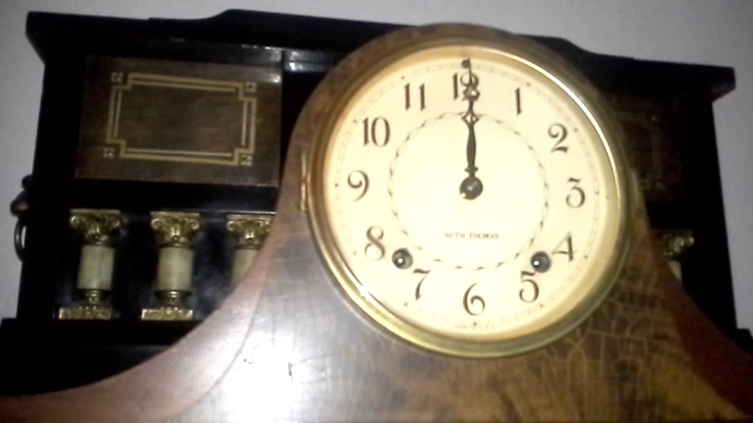

Rabbi Shmuel Munkes once was traveling to spend Rosh Hashanah with his Rebbe, Rabbi Schneur Zalman of Liadi, when something happened that caused him to be stranded in a small village over Shabbat.
Soon after Shabbat was over, the villagers retired to nap before the start of Selichot at midnight, the solemn prayer for forgiveness that opens the High Holiday season.
Several minutes before the time arrived, the shamash (shul manager) began making his rounds with a lantern in one hand and a wooden mallet in the other, pounding on the shutters of each home and calling, "Wake up! Wake up! Wake up to the service of the Creator!" The entire village climbed out of bed, dressed swiftly, and hurried to the brightly lit synagogue.
In the home of Rabbi Shmuel's host there was much confusion. The entire family had dressed and gathered at the door, prayer-books in hand, ready to depart for the synagogue; but their prestigious guest had yet to emerge from his room. Finally, the villager knocked softly on Rabbi Shmuel's door. No response. Slowly he entered the room. To his amazement, he found the pious chasid sound asleep.
"Reb Shmuel, Reb Shmuel," he urged, shaking his guest awake. "Come quickly. Selichot!"
Rabbi Shmuel's only response was to burrow even more deeply under the covers.
"Hurry, Reb Shmuel," his host persisted. "They're about to begin in the synagogue any moment now."
"Begin what?" asked Rabbi Shmuel, quite obviously annoyed. "It's the middle of the night. Why are you waking me in the middle of the night?"
"What's the matter with you?" cried the villager. "Tonight is Selichot! A fine Jew you are! Why, if I hadn't woken you, you would have slept through the entire Selichot!"
"Selichot?" asked Rabbi Shmuel. "What is Selichot?"
Rabbi Shmuel's host was beside himself with incredulity. "Are you mocking me? Didn't you know that today was the Shabbat before Rosh Hashanah? Every man, woman and child of the village is now in the synagogue, trembling with trepidation. Soon the Prayer Leader will begin chanting the Selichot prayers and the entire community will burst into tears, praying and begging G-d to bless them with a good year..."
"So that's what this commotion is all about?" asked Rabbi Shmuel. "You're going to the synagogue to pray? What's so urgent that can't keep until morning? What are you praying for?"
"There's so much to pray for, Reb Shmuel," sighed the villager. "I pray that the cow should give enough milk to keep my children healthy. I pray that the oats should fetch a good price on the market this year, for soon I shall have a daughter to marry off. I pray that my horse should not break a leg, G-d forbid, as happened the year before last...."
"I don't understand," interrupted Rabbi Shmuel. "Since when do grown men wake up in the middle of the night to ask for a bit of milk?"
~~~~~~~~~~~~~~~~~~

Source: Adapted by Yerachmiel Tilles from //chabadtalk.com/forum/showthread.php3?t=1953.
Biographical note: Rabbi Shmuel Munkes (1834-1882)], an elder disciple of Rabbi Shneur Zalman of Chabad, was known for his fervent and creative Chasidic service. Stories abound of his sharp wit and "chasidic pranks". He lived in Beshenkovitz and then in Kalisk (or the reverse?) in (or near?) the district of Polotz.

Reprinted from the September 27, 2016 email of Kabbalah Online, a project of Ascent of Safed.
Brooklyn torah gazette
For rosh hashanah 5778
Volume 2, Issue 1 (Whole Number 43) 1 Tishrei 5778/ September 21, 2017
Printed L’illuy nishmas Nechama bas R’ Noach, a”h

For a free subscription, please forward your request to keren18@juno.com

Keeping the Honey in the Land of Milk and Honey
By Dana Kessler
Just in time for Rosh Hashanah, Israel’s annual honey festival shines a light on the variety of sweet products being produced—as well as the challenges facing the country’s beekeepers

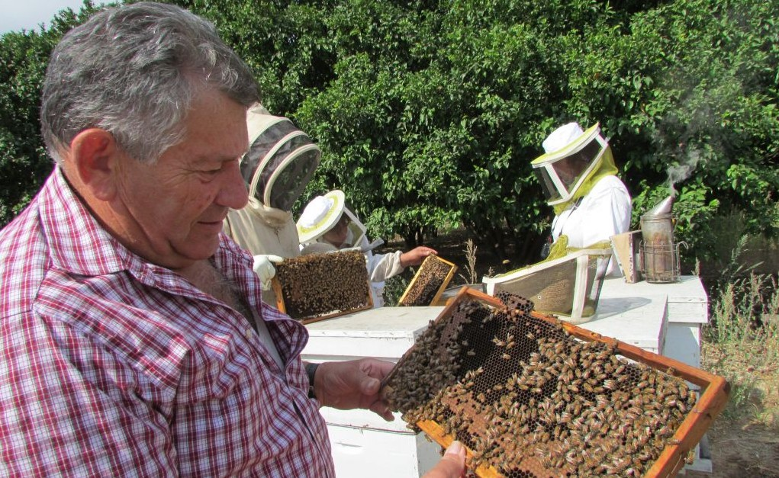
Haim Efrat, head of the Ministry of Agriculture’s beekeeping division and one of Israel’s foremost experts on the bee, examines a hive. (photo credit: Debra Kamin)
Forty percent of the honey consumed in Israel every year is consumed during the High Holidays , when it is customary to eat honey and give it as a gift. So, just in time for Rosh Hashanah, the Israeli Honey Board is kicking off its annual honey festival at apiaries across the country. The festival, spread across more than 10 locations, started Sept. 22 and will continue until Oct. 29, after Sukkot ends.
The festival’s activities include tours, honey tastings, and a photography competition (the family that snaps “the sweetest photo” at one of the festival’s attractions will win a prize). Visitors will have an opportunity to watch the bees in a glass beehive, talk to beekeepers, and witness the process of honey extraction, while kids will have the chance to engage in honey-themed arts and crafts, bake honey cake, and dress up as honeybees.
There are around 500 beekeepers in Israel who manufacture honey: 100 are commercial manufacturers who are responsible for around 80% of Israel’s honey, while the other 400 are small, boutique manufacturers or amateur bee enthusiasts. Together they produce about 3,000 tons of honey each year. (Israel imports an additional 1,000 tons from Europe and South America.)
The Israeli honey industry also produces bee pollen, royal jelly, propolis , and apitoxin (also known as honeybee venom, used in a branch of alternative medicine called apitherapy ). The Israeli Honey Board’s job is to improve the quality of Israeli honey by setting standards, crafting legislation, and inspecting honey production and packaging.
Kibbutz Yad Mordechai in southern Israel started making honey in 1936, learning the secrets of beekeeping from Australian and British soldiers during the British Mandate. Today, Yad Mordechai is Israel’s largest honey marketer—now owned by Strauss, Israel’s largest food-products manufacturer.
Under Strauss, Yad Mordechai markets its own honey , as well as honey produced by others. Emek-Hefer Apiary , established in 1981 in northern Israel, is the second-largest honey company in Israel, marketing honey from a number of apiaries across the country. The third-largest is the Ein Harod Apiary , established 80 years ago on Kibbutz Ein Harod in northern Israel.
Retailers stock honey from these larger marketers. But for specialty honey, the best bet is to go directly to the apiaries. Many of them have their own boutique shops and visitor centers, and they’re happy to teach visitors about honey and provide them top-of-the-line boutique honey products all year long.
For example, Lin’s Bee Farm in Kfar Bilu, a moshav in central Israel, is a family-run company that has been producing a wide range of products based on honey and other natural ingredients for 30 years. There’s a visitor center and a shop on the premises, as well as an online store. Like most Israeli manufacturers, Lin markets gift packages especially for Rosh Hashanah.
What makes one honey higher quality than another? “The main difference is the flowers the honey is made of,” explained Youval Lin, beekeeper and owner of Lin’s Bee Farm. “In Israel, eucalyptus, avocado, hyssop, and siziphushoney are high-quality honey, sold mainly by boutique sellers.”
The honey on supermarket shelves is wildflower honey, which is polyfloral—derived from the nectar of different kinds of flowers. Hertzel Avidor, CEO of the Israeli Honey Board, added: “Feinschmeckers [gourmets] prefer monofloral honey, which is made from the nectar of one type of flower, and they know exactly which flowers they prefer, be it star-thistle honey, siziphus honey, [or] thyme honey.”
The other major difference is between honey that has been heated during bottling, and honey that hasn’t. The honey on supermarket shelves has been heated; the heating process stops crystallization and makes the honey look better. Unheated honey can be found at boutique sellers’ and some health-food stores. Many believe that heated honey loses some of its nutritional value, although this is debatable. What it undoubtedly loses, according to Avidor, are some of its healing, antibacterial, and antiseptic properties .
The belief that honey has healing properties isn’t new. Avidor told me that in ancient times, the Egyptians, Babylonians, Persians, Assyrians, and Arabs used honey for embalming their dead. “After King Herod ordered his wife, Marianne, to be executed,” Avidor said, “he kept her body in honey for seven years—supposedly because he loved her so much.”
***
There are challenges facing Israel’s honey industry today. Like other beekeepers around the world, Lin is concerned with colony collapse disorder . “There is a problem in the modern Western world that kills bees around the world,” he told me. “In Israel, the problem is less severe than in the U.S. because our climate is more suitable to keeping bees, but we have this problem, too. This affects not only the honey industry and the livelihood of beekeepers but also many different crops that rely on pollination. In Israel, it affects mainly apples, cherries, sunflowers, melons, watermelons, zucchini, and almonds. This is a very serious problem which was identified about 10 years ago, and a solution is yet to be found.”
Avidor also notes that Israel’s size puts a limit on the number of beekeepers it can sustain. “We are a small country, and we don’t have enough space—therefore we can’t increase the number of apiaries we have,” he told me. “We are one of the most crowded countries in terms of beehives. There are 110,000 beehives across the country, from Beersheva to the north. You can’t place beehives south of Beersheva because there is no vegetation there. We can’t add any more beehives, and thus the industry can’t grow.”
Changes in Israeli agriculture have also put pressure on the country’s honey production. “In the ’70s and ’80s, there were plenty of citrus trees, mainly orange trees, and there was also a lot of cotton—two important crops for making honey,” said Avidor. “Because of the country’s process of urbanization, orchards are being extracted, and there are much fewer crops bees can forage nectar from.” The Jewish National Fund is helping beekeepers plant different types of trees especially for their nectar, said Avidor, so their bees can survive.
While Israel’s honey industry cannot really expand, it can develop. “There are many technological developments in the field,” Avidor said. “One of the new Israeli developments is an electronic scale which is placed under the beehive. It sends data about the beehive digitally to a website, so the beekeeper can check in from home and keep track of the activity in his beehives.”
Apart from promoting honey—the everlasting Jewish symbol for having a good and sweet New Year—the purpose behind the annual honey festival is raising awareness of the problems facing the industry in Israel. “We want the public to know about our struggle to keep bees alive,” said Avidor. “We need the public to support our struggle against pesticides and to support our tree-planting. People need to realize the importance of this. The importance of keeping our bees alive goes way beyond honey. This is about the importance of pollination. Without bees, we won’t have food.”

Reprinted from the September 28, 2016 email of Tablet Magazine.
Rosh Hashana Advice from The Brigadier General
By David Bibi

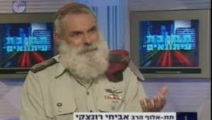
General Rabbi Avichai Rontzki

When we spend Shabbat in Manhattan with Rabbi Elie Abadie, it's always a curiosity as to who will show up for breakfast at the SAFRA synagogue [in Manhattan] on the morning. Two very special visitors joined us this weekend. One was Rabbi Nissim Ze'ev a well-known student of Porat Yosef, who has served as a Rabbi, Shochet, Mohel and Chazzan in Israel, in Mexico and here in New York. He is probably most famous for being the one who started the Shas party in Israel and he still represents Shas as a member of the Knesset.
Rabbi Ze'ev was very close to Haham Ovadia Yosef zs'l and as this coming Shabbat is when the 12 months of mourning for the Rishon LeSion conclude, Rabbi Ze'ev told us of his earliest relationship with the Rabbi who lived in the same building as his grandmother. He entertained us with other personal anecdotes and reminded us of how special Haham Ovadia was and how much we have lost. It was Haham Ovadia who made us and the rest of the Jewish people take pride who we are, where we come from and what we can accomplish.
The other guest was Brigadier General Rabbi Avichai Rontzki, the former Chief Military Rabbi of the Israel Defense Forces. He is also the rosh yeshiva of the Hesder Yeshiva in Itamar and a founder of that city in the Shomron. Rabbi Rontzki also wrote the highly acclaimed four volume army halachic guide Hitzim K'yad Gibor. As we spoke privately afterwards, we discussed politics and the press and his recent but unwanted publicity. More important though, the rabbi is a brilliant scholar and we discussed a message for Rosh Hashanah which probably applies to almost all of us.
The rabbi grew up in a secular family and found himself in 1973 as a commander in the army. We must remember that only six years earlier Israel had delivered a stunning blow to its Arab neighbors defeating them miraculously in the Six-Day War. The relationship between Israeli and Arab had changed forever. Even more so the image of the Jew had been transformed in the eyes of the world. The Israeli army's crushing victory had altered the image of a Jewish victim into a Jewish warrior.
The Israelis believed that they would find themselves at peace with their Arab neighbors for at least a generation or more. They supposed that they would not be bothered for 20 to 30 years after the Arab world saw the strength of their military. Yet at the same time only two weeks before Yom Kippur of that year the Israeli Prime Minister Golda Meir met with King Hussein of Jordan.
The King informed the prime minister that the Arabs were preparing for war. And this was not the only sign. From the end of 1972, Egypt began a concentrated effort to build up its forces, receiving MiG-21 jet fighters, SA-2, SA-3, SA-6 and SA-7 antiaircraft missiles, T-55 and T-62 tanks, RPG-7 antitank weapons, and the AT-3 Sagger anti-tank guided missile from the Soviet Union and improving its military tactics, based on Soviet battlefield doctrines. What was happening seemed obvious.
And then, only three days before Yom Kippur, 600 family members of Russian diplomats were suddenly evacuated from Syria and Egypt. The Israelis certainly took note of this, but wrote it off as a mass vacation. Why? Human nature often allows internalized preconceptions to mask the stark face of reality. In the minds of Israeli leaders, there was no way the enemy would attack so even when the evidence pointed in the opposite direction, the facts simply couldn't be true.
But unfortunately a few days later, on the Holiest day of the year, we found out that it was true and so many lost their lives, possibly needlessly. The Egyptians and Syrians both initially made threatening gains into Israeli-held territory. Then somewhat miraculously, the tide was turned. It was through this that the rabbi and his wife Ronit who he had met in his unit set together on the path to be chozer beTeshuba “ to return religiously. The Rabbi went on to study at Machon Meir and Mercaz HaRav.
The rabbi went on and explained this fault of being blinded to the truth raises its ugly head time and time again. The brigadier general suggested that it was obvious to everyone that Hamas was building tunnels in Gaza. Weren't the dangers that the tunnels presented obvious? Yet the obvious was ignored.

Reprinted from the Rosh Hashana – Ha’Azinu 5775 edition of Shabbat Shalom from Cyberspace.
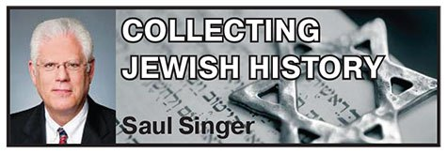
Rosh Hashanah Greetings From Sandy Koufax

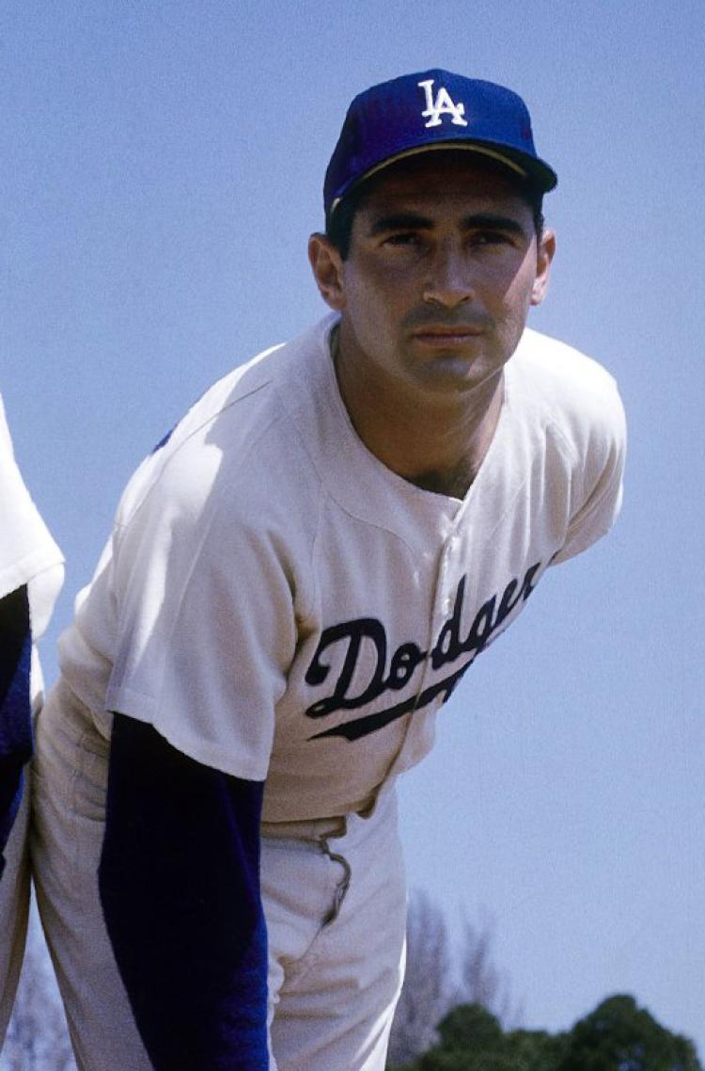

Universally recognized as one of the greatest pitchers in major league history, Sandy Koufax, an “aristocrat in spikes,” threw four no-hitters, dominated the major leagues for the first half of the 1960s, broke numerous strikeout records, and led the league in ERA for an unprecedented five consecutive years.
He was the first person to win the Cy Young award three times, each time by a unanimous vote and each time by winning the “pitcher’s “triple crown” (wins, strikeouts, and ERA). He won two World Series MVP awards, and he is still the only person to win the Hickok Belt (the award for professional athlete of the year) twice.
Much more can be written about Koufax’s baseball feats and records, but to Jews around the world he will always be remembered for his legendary decision not to pitch in the first game of the World Series against the Minnesota Twins on Oct. 6, 1965 because it was Yom Kippur.
His act of conscience was broadly seen as a moment of pride, sacrifice, and religious commitment, though Koufax himself was far from observant. As such, his moral act was not a reflexive response to his personal religious beliefs but rather an act of deference to, and respect for, the sensibilities of his fellow Jews.
Koufax’s place in the annals of American-Jewish history may have been best summarized by Jane Leavy in Sandy Koufax: A Lefty’s Legacy: “He was the New Patriarch: Abraham, Isaac, Jacob and Sandy.”
As the Lubavitcher Rebbe’s Minnesota emissary [Rabbi Moshe Feller] pithily advised him during a visit to his hotel room the next day, “Sandy, more Jews knew when Yom Kippur was this year because of you not pitching than who knew from a Jewish calendar.”
Cultural references to Koufax’s act are legion, but my personal favorite is a quote from film The Big Lebowski, where Judaism is characterized as “Three thousand years of beautiful tradition from Moses to Sandy Koufax.”
When Koufax first announced his decision, Dodgers owner Walter O’Malley, a Roman Catholic, joked to reporters, “I’m going to ask the pope to see what he can do about rain.” Koufax’s teammates were essentially ambivalent but respectful of his decision, even after the substitute starter, Don Drysdale, lost the game. When manager Walt Alston removed him in the third inning after a very poor performance, Drysdale is said to have quipped, “I bet you wish I were Jewish, too.”
Call it divine intervention – or not – but Koufax, after losing Game 2, shut out the Twins in Game 5, came back to win the Series by pitching another shutout in the deciding Game 7, and was named the Series MVP. Interestingly, a year later, on September 25, 1966, he and Ken Holtzman, the two greatest Jewish pitchers in history, faced off against each other for the only time in their careers – the day after both had attended Yom Kippur synagogue services.
(Holtzman, who lost a bid for a no-hitter in the ninth inning, won the game, 2-1).
Though there have a number of media accounts concerning Koufax’s participation in Yom Kippur services that famous day in Minnesota in 1965, and though many Jews claimed to have seen him at various synagogues in Minneapolis, he actually never left his hotel room. (Although, by his own account, he did not view the game on television or listen to radio broadcasts.) As he later explained: “I’m Jewish. I’m a role model. I want them to understand they have to have pride.”
(Holtzman, who lost a bid for a no-hitter in the ninth inning, won.

On the rare occasions he has commented on his decision to sit out the game, he claimed it was actually his customary practice and that he always observed the holidays by not pitching. For example, in his autobiography published in 1966, a year after he attained Jewish immortality, he wrote:
“There was never any decision to make…because there was never any possibility that I would pitch. Yom Kippur is the holiest day of the Jewish religion. The club knows I don’t work that day.”
In the 2010 documentary “Jews and Baseball: An American Love Story,” Koufax confirmed that “I had taken Yom Kippur off for 10 years. It was just something I’d always done with respect.” However, Koufax had “suited up” on Yom Kippur on at least two previous occasions, although he did not actually throw his first pitch until after sundown. On October 1, 1960, he pitched in relief against the Chicago Cubs and, on September 20, 1961, he started against the Cubs, throwing his first pitch mere moments after the end of Yom Kippur.
On August 11, 2014, I wrote to Koufax (in part): “Looking back on it today, is your decision to sit out the World Series because of Yom Kippur something that you are proud of, is it something you ever think about when you reminisce about your career? And were there any factors or issues that were particularly important to you in leading to your decision to take a moral and ethical stand?”
Koufax autographs are valuable, desirable, and very difficult to obtain; handwritten letters even more so; and correspondence relating to his sitting out the World Series on Yom Kippur is virtually unheard of.
In his response to my letter, exhibited with this column, Koufax, consistent with the broad measures he takes to protect his personal life and privacy, does not elaborate on his reasons, but does confirm that his motive for sitting out the game was “respect,” presumably for Jewish tradition:

“While I appreciate your interest, my motives & thoughts are private and will always remain so. Respect might be the one applicable word. A very happy new year.”

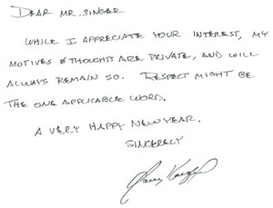

* * * * *
In the further spirit of the intersection of baseball with the Yomim Noraim, exhibited with this column is a fascinating and historic document evidencing an attempt by the New York Yankees early in the 20th century to reschedule a game falling on Rosh Hashanah. In this September 8, 1915 Western Union Telegram to B.B. (“Ban”) Johnson, president of the American League, Yankees co-owner Yankees Tillinghast L’Hommedieu (“T.L.”) Huston writes:
Tomorrow, Sept. 9th is big Jewish holiday in New York. If you will allow us to play Friday’s game as a double header tomorrow, I think it would be most advantageous to both clubs. Will appreciate immediate reply so if permission is granted I can give it out to papers this afternoon.

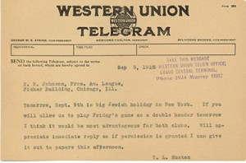

Obviously, Huston was not thinking about Orthodox Jews when he sought to reschedule Friday’s game, which fell on the second day of Rosh Hashanah, as a doubleheader on Thursday, the first day of yom tov. Presumably aware that few Jews stayed home from work on the second day of yom tov, Huston apparently sought to increase attendance on the first day of Rosh Hashanah by scheduling a twin bill for the day most Jews did stay home – and when even those who attended services in the morning could come out to the ballpark in the afternoon.
It is amusing to note how easy it was for the major leagues a century ago to reschedule a game on such short notice – in this case, a single day. Huston’s request was apparently granted by the American League because a doubleheader was played on the first day of Rosh Hashanah, Thursday, September 9. The Washington Senators defeated the Yankees in both games, 5-3 and 4-1, and the New York team finished fifth that season (in an eight-team league) with a record of 69-83.

Saul Jay Singer
About the Author: Saul Jay Singer, a nationally recognized legal ethicist, serves as senior legal ethics counsel with the District of Columbia Bar. He is a collector of extraordinary original Judaica documents and letters, and his column appears in The Jewish Press every week. Mr. Singer welcomes comments at saul.singer@verizon.net.

Reprinted from the September 28, 2016 edition of The Jewish Press.
31,000 Jews in Uman
For Rosh Hashanah 5777 (2016)
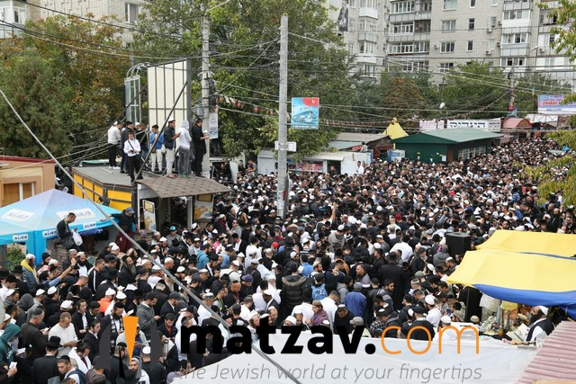

31,000 Jews flocked to the Ukrainian town of Uman for Rosh Hashanah 5777/2016. Every year, the influx of Yidden to the tiny Ukrainian town gives a huge boost to local businesses.
Police officers from Israel and hundreds of Ukrainian law enforcement officers were on hand to provide security.
Interestingly, many of the local Uman shops on Pushkin Street take payment in shekels. Everywhere, there were signs and ads in Hebrew.
Uman, a town of 80,000 residents, is located about 130 miles south of Kiev. It is, of course, home to the kever of Rav Nachman of Breslov, who was niftar there in 1810.
According to a local official, this year, 31,000 visitors traveled to the city for Rosh Hashanah, including about 3,000 children but just a few dozen women.
For comparison, last year (5775/2015), 29,450 Jews went to Uman for Rosh Hashanah.
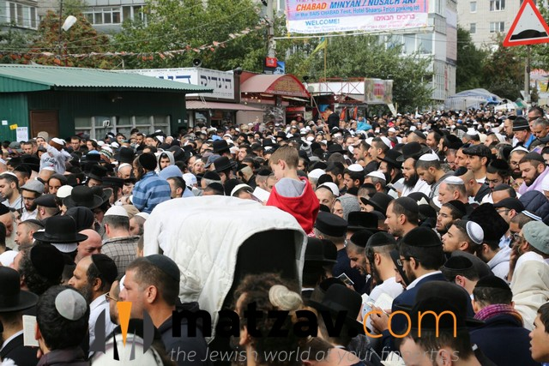
Around 15 Israeli police and 500 local police kept order, guarding entrances to a two-block area of town that remained closed off to all locals except those who live there for the duration of the week.

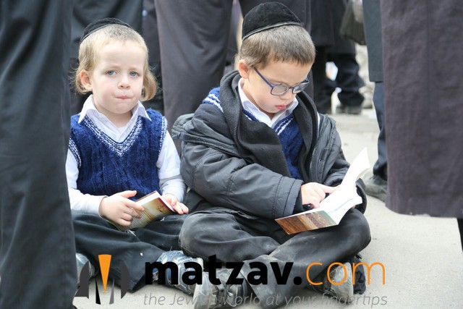

Reprinted from the October 5, 2016 website of Matzav.Com

